7 Secret Ingredients

In the Caribbean where chicken, pork and fish are frequently on the menu, many chefs and cooks use green seasoning to give the meat the perfect island spice and flavor. A mixture of herbs and other aromatics, it’s used as a marinade for meats and seafood, flavoring for stews and curries and many cooks put a spoonful into soups and rice dishes to give the food that quintessential Caribbean flavor. It’s a staple of kitchens in the islands. It’s a raw sauce and can be used before or after foods are cooked.
While building a culinary tour in the Caribbean, I learned a combination of ingredients and techniques used by my business partner Chef Herbert, home cooks like his sisters, street chefs and award winning international chefs called Green Seasoning. This now is the combination known as 7 Secret Ingredients and is the standard blend we use in our cooking classes in Saint Lucia and now showcased around the world and available for your kitchen.
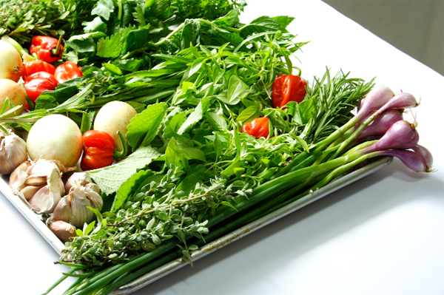
The core ingredients are garden-fresh ingredients like local peppers, onion, garlic, thyme, salt with other ingredients added depending on the specific tastes of an island or region. Some blends include celery or papaya or hot pepper. Some cooks add cinnamon and many versions include cilantro or locally grown succulent called chadon beni. The flavor profile will differ with the cook and the region. Because Caribbean cooks are masters of making do with what they have on hand, green seasoning will vary from batch to batch.

Traditionally, green seasoning is made fresh daily and is found in many kitchens. In the old days, the ingredients were ground on river stones and used to flavor the meals for the day. Still in many kitchens it is still made daily using a pestle and mortar, blender or food processor, but it’s also available for purchase in markets and grocery stores throughout the Caribbean and beyond. Not only is green seasoning a powerhouse of flavor, but it’s nutritious. In addition to vitamins and minerals, it provides fiber.

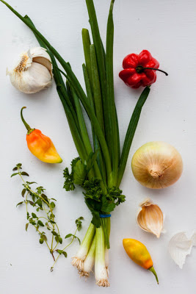

Throughout the Caribbean, green seasoning is an essential ingredient in many recipes. It provides the complex flavor profile that makes the dish uniquely tropical West Indies flavor.
If you can’t get to the islands to cook with us or it will be a while until you can return for another visit, you can make your own green seasoning with items easy to find in most markets, there is often a reasonable substitute. If you want to duplicate deep, delicious authentic flavor you must make green seasoning and marinade your meat overnight or at least for a few hours. We will often squeeze a bit of lemon or lime on mixture before covering and refrigerating.

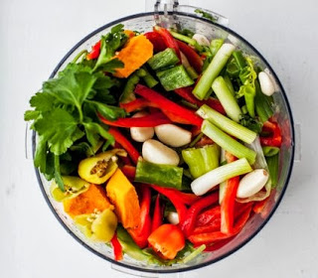
7 Secret Ingredients Recipe
Ingredients with Patois natural names included
1 fat bunch Thyme (remove thick stems) or Gwo Diten
1 small bunch Cilantro or Chadon Beni
6-12 cloves garlic, peeled (you can use more or less depending on your taste) or L’ai
1 fat bunch of green onion or Ti Lonyon peeled and chopped
10-12 small sweet pepper or seasoning peppers, seeded or Pimon
1 stalk large celery or Celwi
1 teaspoon salt
Just a few drops of water to make it into a sauce.

Optional Ingredients
2 small hot peppers, seeded
6 pimento peppers, stemmed
Habanero, congo, scotch bonnet, cherry pepper or other hot pepper, to taste
Dab of Cinnamon
Chunks of Pumpkin
Chunks of papaya
Chunks of Mango

Wash all the ingredients. Roughly chop the ingredients and toss them into a food processor or blender. Process them until they’re pureed. (Some cooks prefer a chunkier version so feel free to use your judgement.) Pour the sauce into jars and store for one to two weeks.

If you’d like to preserve the mixture longer, use an ice cube tray. Fill each well about 2/3 full and cover the tray with wrap and place them in the freezer. When the cubes are frozen, pop them into a freezer bag, like Ziploc, and place them in the freezer. When you need some Caribbean flavor, defrost one and use it!

